CONFIDENTIAL

Project name: ANTI RAGGING PORTAL

Class Design Specification

DOCUMENT VERSION HISTORY

Document Version | Date Issued | Comments
1.0 | 22 – 10 - 2019 | First version of the Web Portal

Table of Contents

Table of Contents 2
Class Design
1 Introduction 3
2 Conventions followed 3
3 Class Diagrams……………………………………………………………………………………… 4-7

1 . Introduction

The class diagram is the main building block of object oriented modelling. It is used both for general conceptual modelling of the systematics of the application, and for detailed modelling translating the models into programming code. Class diagrams can also be used for data modeling. The classes in a class diagram represent both the main objects and or interactions in the application and the objects to be programmed. In the class diagram these classes are represented with boxes which contain three parts:
A class with three sections:
- The upper part holds the name of the class
- The middle part contains the attributes of the class
- The bottom part gives the methods or operations the class can take or undertake

Conventions followed

Hungarian Convention

Class Diagrams

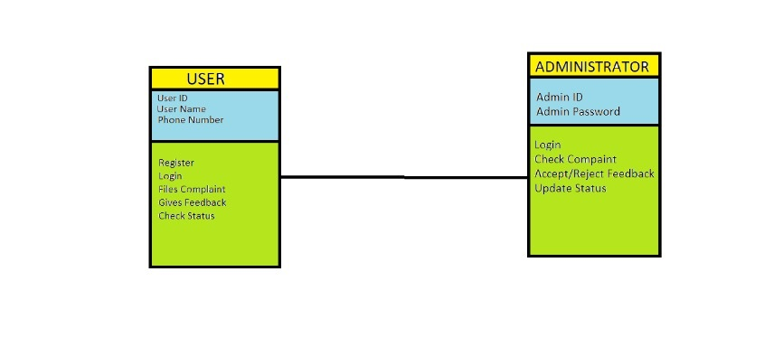

Admin
Class Description:
The Administrator class holds those attributes and functions which may be used for the functioning of the system. The administrator manages staff, parent and student.
Methods
 | Function | OutPut Parameters | Description
1 | login(String, String) | text | checks for the authentic username and password and provides the login
2 | Update Status(option) | text | The administrator updates the status of user complaints and feedback.
3 | Accept/Reject feedback and complaint(option) | Text | The administrator accepts/rejects the complaint and feedback.

User
Class Description:
The Student class contains the attributes and related functionality for the students

Methods
 | Function | OutPut Parameters |  | Description
1 | register(String, String, String, String, String, String, String, String, String, String, String, String, String, String) | Text |  | registers the new student in the portal
2 | Login(String,String) | Text |  | authenticates the student to login
3 | Feedback and complaint(String) | Text | Give feedback and complaints.

